Same-Sex Marriage (Draft)
Introduction
Same-sex marriage is currently one of the most divisive political issues in our nation. In November 2008, Californians passed Proposition 8, a referendum that removed the right to marry from same-sex couples who had been granted that right by the courts. This result has been seen by the same-sex community as deeply degrading. Analyzing this issue will help us understand what is happening in our country, and where we might go from here (Nussbaum, 2009).
A growing number of governments around the world are considering whether to grant legal recognition to same-sex marriages. So far, more than two dozen countries have enacted national laws allowing gays and lesbians to marry, mostly in Europe and the Americas. In Mexico, some jurisdictions allow same-sex couples to wed, while others do not (Pew, 2017).
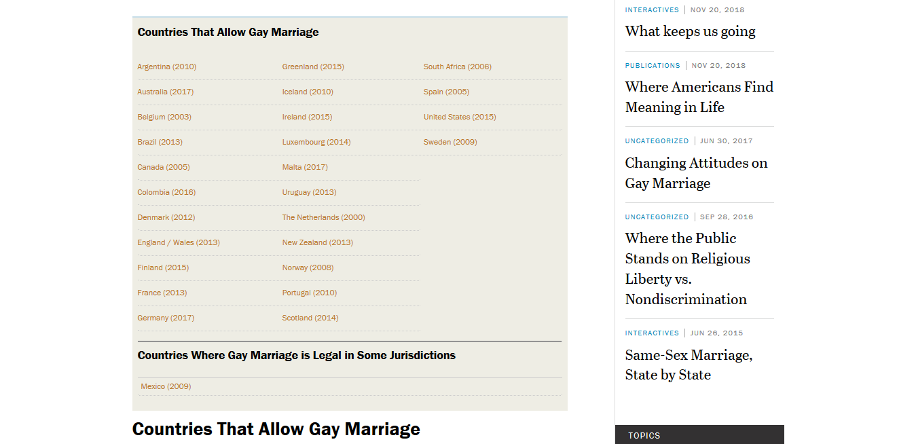
(Source: Pew, 2017a).

Opposition to Same Sex Marriage
Emotive arguments and questionable rhetoric often characterise debates over same-sex marriage. But few attempts have been made to dispassionately dissect the issue from an academic, science-based perspective (Anderson, 2018).
Opposition not supported by science or academia but emotions or religious background.
Why Same-Sex is Legal
Same-sex marriages were recognized by the federal government in 2013 when the Supreme Court invalidated a key provision of the 1996 Defense of Marriage Act (Windsor v. United States) and allowed same-sex couples to be treated as married for all federal tax purposes, as long as they were legally married in a state that recognized their marriage (Looney et al, 2018).
In 2015, the court went further, establishing via their decision in Obergefell v. Hodges that same-sex couples have the right to marry in all states. The 5-4 decision in Obergefell v. Hodges legalized gay marriage nationwide, including in the 14 states that did not previously allow gays and lesbians to wed. The decision rested in part on the court’s interpretation of the 14th Amendment; the justices ruled that limiting marriage only to heterosexual couples violates the amendment’s guarantee of equal protection under the law (Kiley et al, 2017).
Facts and Statistics
Public support for same-sex marriage has grown rapidly over the past decade. In 2007, Americans opposed legalizing same-sex marriage by a margin of 54% to 37%. A new Pew Research Center survey finds that around two-to-one, more Americans support (62%) than oppose (32%) allowing gays and lesbians to marry legally.
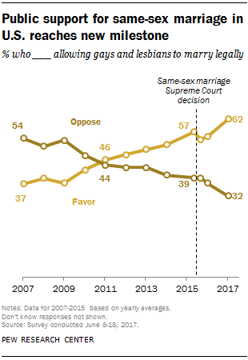
Although support has increased across the board, demographic divides over same-sex marriage remain. Differences are particularly pronounced among religious groups. Today, 85% of Americans who are religiously unaffiliated favor same-sex marriage, as do 68% of white mainline Protestants and 67% of Catholics. Among black Protestants, 44% favor same-sex marriage (50% oppose). And while just 35% of white evangelical Protestants favor same-sex marriage, this is more than double the level of a decade ago (14% in 2007). Generational differences also remain wide, though support among older generations also is on the rise: 74% of Millennials (now ages 18 to 36) and 65% of Generation Xers (ages 37 to 52) now support same-sex marriage, compared with 56% of Baby Boomers (ages 53 to 71) and 41% of those in the Silent Generation (ages 72 to 89).
Same-sex marriages are on the rise. Surveys conducted by Gallup over the past year find that about one-in-ten LGBT Americans (10.2%) are married to a same-sex partner, up from the months before the high court decision (7.9%). As a result, a majority (61%) of same-sex cohabiting couples are now married, up from 38% before the ruling.
In general, overall rates of same-sex filing in 2015 were highest in states that had legalized same-sex marriage prior to 2013 or in 2013. In states that had not legalized same-sex marriage until 2015, rates were relatively lower up to and including the year 2015. The percentage increase in same-sex filing, however, was relatively high in those states (Looney et al, 2018).
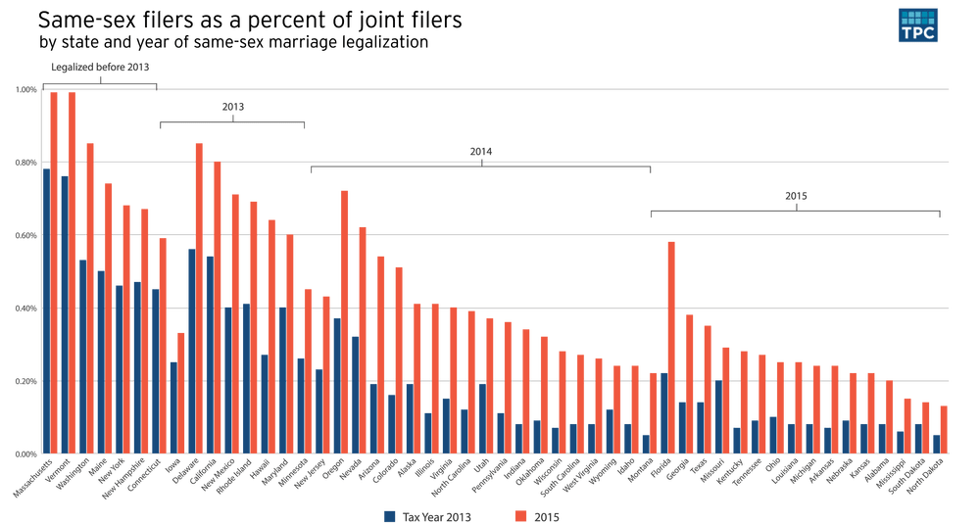
(Source: Brookings, 2018).

Conclusion
Marriage is an important rite of passage in many societies and cultural traditions.
Combined with family, it provides the early foundation for shaping morals and socializing children.
Legal marriage brings with it recognition and rights from various private and state apparatuses including health care benefits, social security benefits, tax benefits along with positive social status. “It is an economic institution. It is about property.

It is not about human relations, or intimate relations”

Same-sex couples may also face challenges within their communities and families due to lack of acceptance and understanding. Several choose to remain silent and hidden within and outside of their communities due to prevailing adverse cultural and family beliefs, religious
traditions, racism and homophobia
LGBTQ people face “the sting of social disapproval and the persistence of discrimination in nearly every facet of everyday existence” (Wolff, 2017).

References
Anderson, R. (2018). Evidence is clear on the benefits of legalising same-sex marriage. The Conversation. Retrieved from: https://theconversation.com/evidence-is-clear-on-the-benefits-of-legalising-same-sex-marriage-82428
Kiley, J., Brown, A. & Masci, D. (2017). 5 facts about same-sex marriage. Pew Research Centre. Retrieved from: http://www.pewresearch.org/fact-tank/2017/06/26/same-sex-marriage/
Looney, A., Gee, G. & Fisher, R. (2018). Gay marriage in America after Windsor and Obergefell.Brookings.
Nussbaum, M. (2009). A Right to Marry? Same-sex Marriage and Constitutional Law. Dissent. Retrieved from: https://www.dissentmagazine.org/article/a-right-to-marry-same-sex-marriage-and-constitutional-law
Wolff, K. (2017). I Do, I Don’t”: The Benefits and Perils of Legalizing Same-Sex Marriage in the United States—One Year Later. Humanities, 6, 12; doi:10.3390/h6020012

